**Cereal Killer 04**

***Reverse***

**Challenge:**

lilith is not too old to have a favorite monster / ghoul / daemon / phantasm / poltergeist / creature / extraterrestrial or a favorite sugary breakfast cereal! She also has a favorite programming language (which no one else at DEADFACE likes that much, and they all think she is kinda weird for it). She probably mainly likes it because it was her first language she learned at the age of 9.

See if you can crack her program and figure out what her favorite cereal and entity are.

Enter the answer as flag{LilithLikesMonsterCereal}.

Attached - CenoBytes.jar

**Approach:**

Easier than the previous ones actually, we got a jar file, hence its java, and we used an online java decompiler such as https://www.decompiler.com/ to decompile this program.

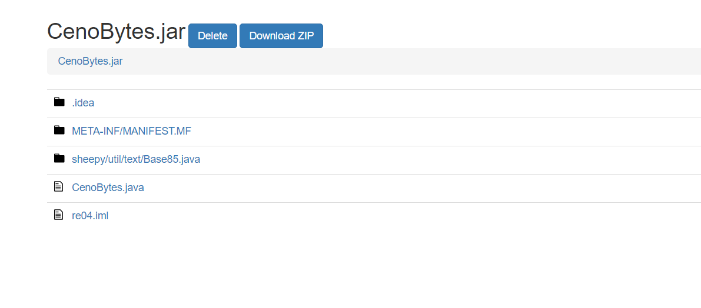

We see 2 java programs, CenoBytes.java and a Base85.java inside the sheepy/util/text folder.

We just copy these java files into our Eclipse IDE to run it locally.

We notice how the program takes input and performs operations on the hardcoded strings to compare it with the input and just craft our input according to it to get the correct result.

Hence getting our flag:

**Flag: flag{OctoberIsSharkMonth}**

Congrats!!

Happy Hacking!